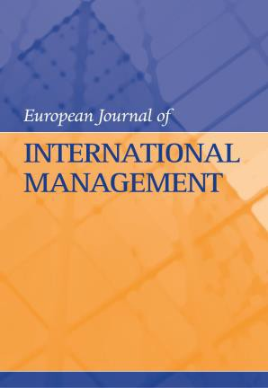

European Journal of International Management

XXVIII Portuguese-Hispanic Conference on Scientific
Management/HELIX 2018/IRMBAM2018:
Special Issue on: “International Entrepreneurship and
Internationalisation Processes: Exploring Trends and Gaps”

Guest Editors
Prof. Marta Peris-Ortiz, Universitat Politècnica de València, Spain
Associate Prof. João J. Ferreira, University of Beira Interior, Portugal

In the internationalisation process, the environment is global and competitive, increasingly complex and technologically uncertain. Hence the need for dynamism and proactiveness, and one way to achieve this is through international strategic alliances (Nielsen, 2007). Alliances can be an attractive option to enable small businesses to exploit their valuable resources,
gain access to markets (Miles et al., 1999) and enable better performance.

A number of researchers have showed that international entrepreneurship lacks a vigorous theoretical framework due to the presence of inconsistent views of the entrepreneurial component of internationalisation and knowledge gaps related to the discrepancy of international business and entrepreneurship theories in international entrepreneurship (Kiss et al., 2012).

This new-found interest in international entrepreneurship and internationalisation-related issues may have been triggered by the fact that an increasing number of international and born-global firms around the world recently began to show how their international entrepreneurial nature could result in competitive advantages in a changing and hostile environment.

With this in mind, we would like to invite scholars to share their ideas about the understanding of international entrepreneurship and how it is linked to international processes. By carefully examining trends and gaps, we hope to create, challenge and advance the theory in this field, and to contribute to the existing literature. To achieve this aim, this special issue invites conceptual and/or empirical papers that present cutting-edge research on international entrepreneurship and internationalisation at the micro, meso and macro levels. Papers that examine trends and initiatives, employ original methodologies and offer interesting empirical insights and theoretical contributions to this issue are particularly welcome.

The issue will carry revised and substantially extended versions of selected papers presented at the XXVIII Portuguese-Hispanic Conference on Scientific Management, Regional HELIX
2018 and 9th International Research Meeting in Business and Management (IRMBAM), but we are also inviting other experts to submit articles for this call.

Subject Coverage
Topics include, but are not limited to, the following:

x What is the relationship between international entrepreneurship and internationalisation-related approaches?
x What are the motives, determinants, modes, speed of entry and location patterns of international firms?
x Which theoretical frameworks can be used to analyse the international entrepreneurship of internationalised firms?
x Do the findings on international entrepreneurship and/ or internationalisation of firms challenge existing theoretical models? Why and how?
x What are some of the antecedents and consequences of international entrepreneurship in the internationalisation context and vice-versa?
x What is the impact of international entrepreneurship on the internationalisation processes of firms?
x How does the existing institutional framework shape the international entrepreneurship of born-global firms?
x What are the new theoretical constructs and methodological approaches that can encompass the international business capacity?
x What role does internationalisation play in firms, regions and/or nations?
x What factors influence firms’ internationalisation capacity and performance?
x What are the underlying entrepreneurial, organisational and institutional mechanisms that enable or inhibit the international capacity of firms?

Notes for Prospective Authors
Submitted papers should not have been previously published nor be currently under consideration for publication elsewhere. (N.B. Conference papers may only be submitted if the paper has been completely re-written and if appropriate written permissions have been obtained from any copyright holders of the original paper).

All papers are refereed through a peer review process.

All papers must be submitted online. Please read our Submitting articles page.

If you have any queries concerning this special issue, please email the Guest Editors: Marta Peris-Ortiz: mperis@doe.upv.es
Joao Ferreria: jjmf@ubi.pt

Important Dates

Manuscripts due by: 15 September, 2018

Notification to authors: 15 December, 2018

Final versions due by: 15 March, 2019

